FSAM/MIM USER GUIDE Topics | Page numbers
1.1 Manage Users including | Pages 2 - 4
Search Users | Page 2
Check Group Membership | Page 2
Add Self to Group | Pages 2-3
Remove Self from Group | Pages 3-4
1.2 Manage Groups | Page 5
Search Groups | Page 5
Create a UDC Group | Pages 5-6-7
Create an ORG Group | Page 8
Modify Groups Members | Pages 8-9
Add members to Multiple Groups | Pages 10-11
Mail Enable a Group | Pages 11-12
File Share Enable a Group | Pages 12-13
1.3 Approvals | Page 13
View or Cancel a Pending Request | Page 13
Respond to a request for Approval | Page 14

USER GUIDE FOR FSAM/MIM UPGRADE in MAY 2022

Manage Users

Search Users
Aim | Find a user’s profile in the MIM Portal
Access Role | MIM User
- On the Users page enter a search string in the “Search for” box and click the magnifying glass icon.  - The search string may be:  - The Account Name,  - Part of the first name, or  - Part of the last name.  - Note: do not attempt to search on more than one partial string. | 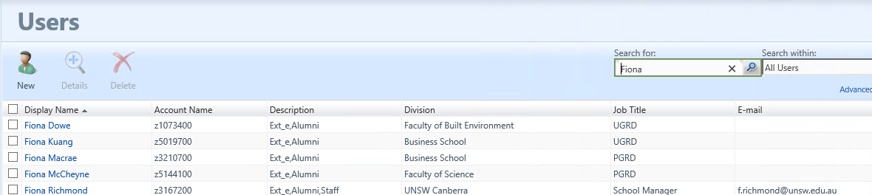
To search among only Staff or only Students, select an option under “Search within” before searching. | 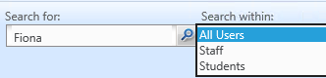

Check Group Membership
Aim | Check membership of a MIM-managed group.
Access Role | MIM User
To see which MIM-managed groups a user belongs to:  Open their profile in the MIM Portal and click the “Membership” tab.  NOTES:  - This only shows direct group membership and does not enumerate groups inherited through nesting.  - Clicking a group name here views the group but cannot edit it – to change a group, locate it through the Groups page. | 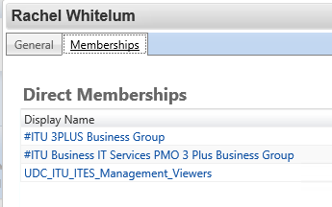

Add Self to a Group
Aim | Add or remove self from a group
Access Role | Member of “MIM Users” Set
Search for the group to join or leave | See 1.2.1 Search Groups
Tick the group and then click the “Join” button | 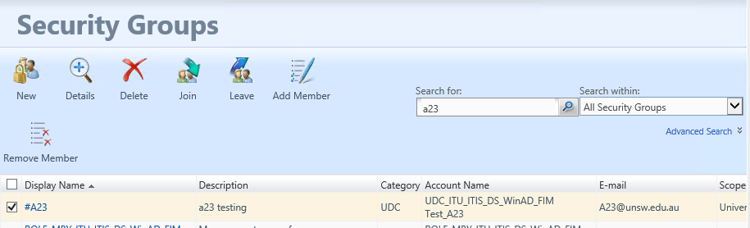
Click Submit | 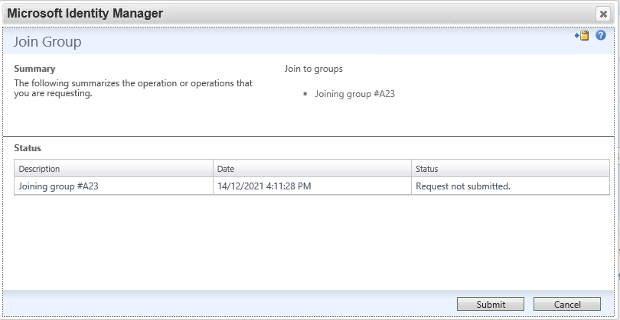
If approval is needed a “Pending approval” message will show up.  Check the status of the approval on the “Manage My Requests” page. | 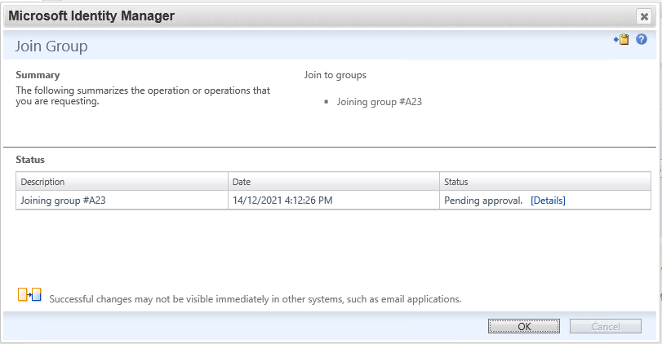

Remove Self from Group
Aim | Add or remove self from a group
Access Role | Member of “MIM Users” Set, current member of group
Search for the group to join or leave | See 1.2.1 Search Groups
Tick the group and then click the “Leave” button
Click Submit | 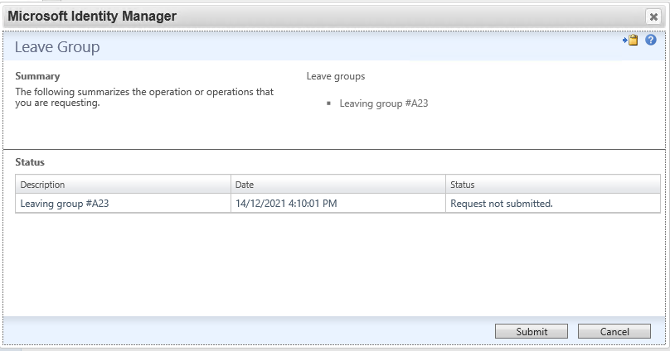
The request completes without approval. | 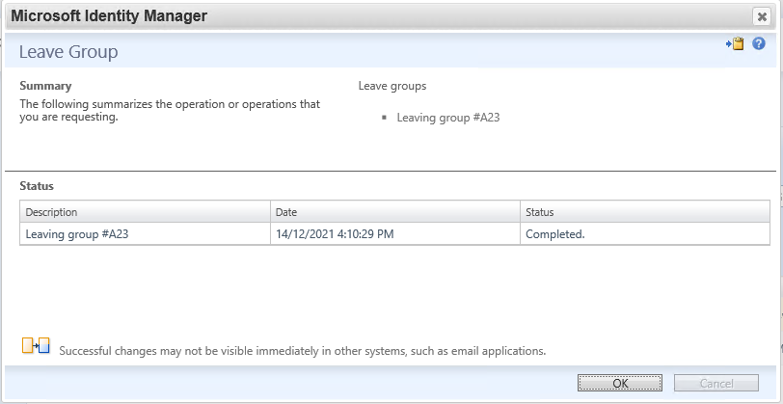

Manage Groups

Search Groups
Aim | Locate a group in the MIM Portal
Access Role | MIM User
In the MIM Portal, click “Groups” on the left side or home page menu. | 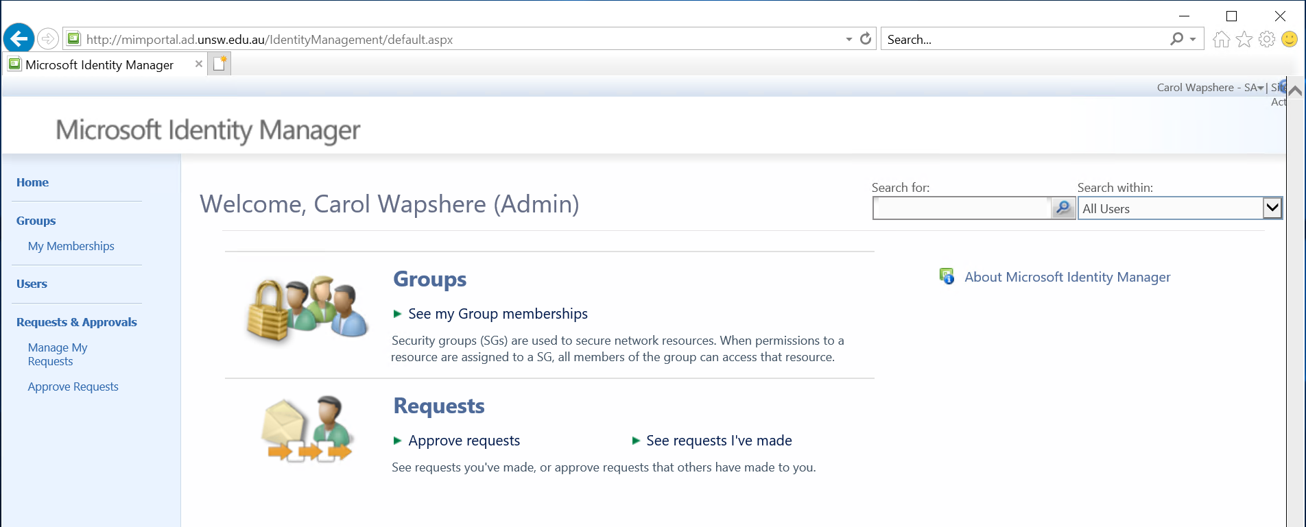
Enter part of the group’s name in the search box and click the magnifying glass icon to search all groups. | 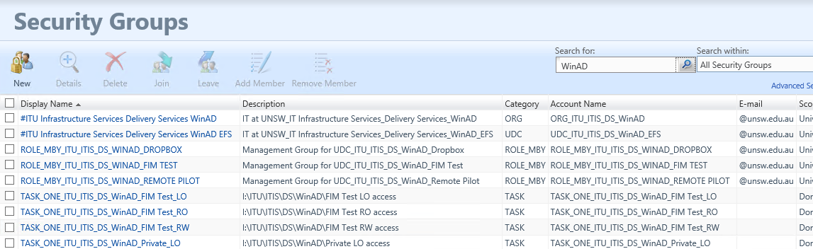
To limit the search to one specific OU, select that from the “Search within” drop-down, before clicking the magnifying glass. | 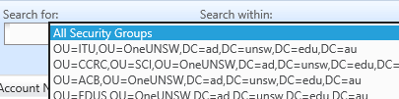

Create a UDC Group
Aim | Create a UDC group
Access Role | MIM User
On the Groups page, click the “New” button.  The Group Creation form appears. | 
Leave on the default option “UDC” | 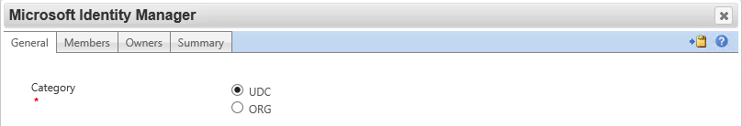
Click the “Browse” button next to “Parent” | 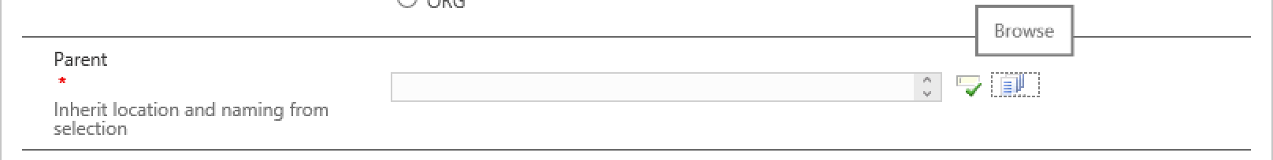
Search for the group that will be hierarchically above this one. The new group will inherit the OU and naming from the selected parent.  Once the parent group is located, tick it, and click “OK”. | 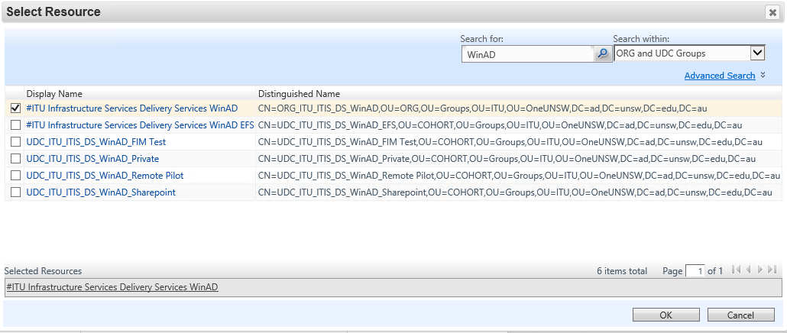
Fill in the Name. This is just the end, user-defined part of the name – it is no necessary to enter the full hierarchical.name.
The “File Share Enabled” and “Mail Enabled” options can either be ticked now, or in a later modification to the group. | 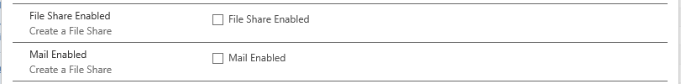
Enter a Description.  Click Next to go to the next tab. | 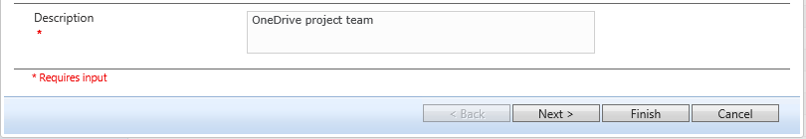
On the Members tab, click the Browse button and search for users to add. | 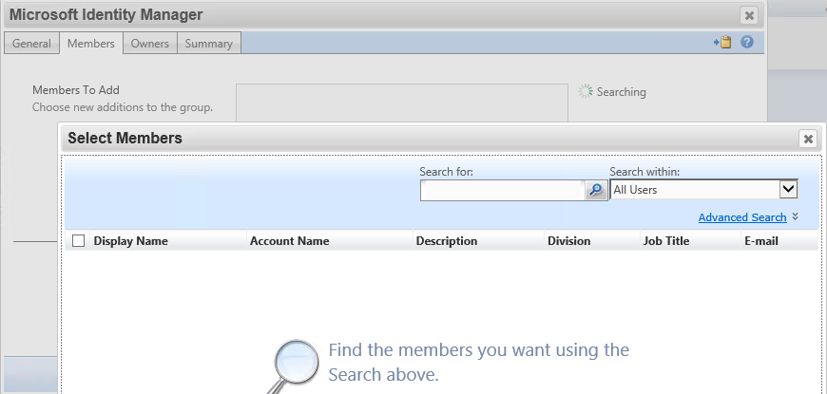
Alternatively, change the “Search within” option to “ORG Groups” and select one or more groups to be members.  Click Next to move to the next tab. | 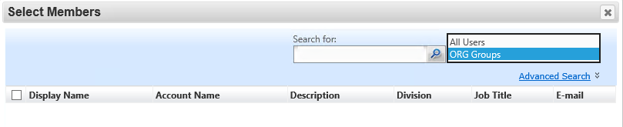
On the Owners tab, click the Browse button and search for the group to be the owner of this new group. | 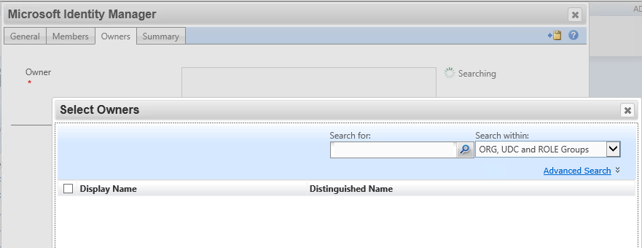
Alternatively, if there is not a suitable existing group, change the “Search within” option to “Staff” and search for users to own the group.  NOTE: At least 3 users must be selected, or else your creation request will be rejected. | 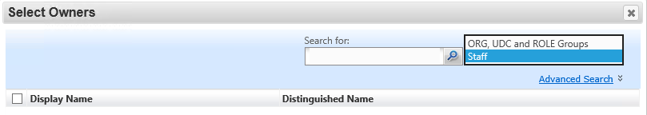
Click Next and check the summary is correct before clicking “Submit”.  If anything needs correcting first, use the Back button to return to a previous tab. | 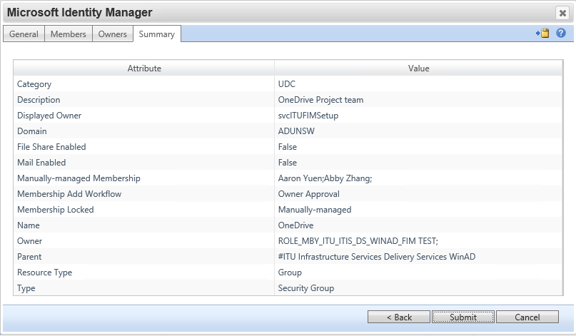
If approval is required, you will see a “Pending approval” status message. The group will not be created until the approval process is complete.  Click OK. | 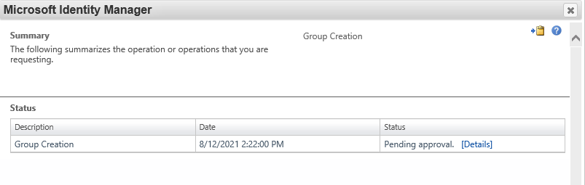
To monitor the status of the request, click “Manage My Requests” on the left side menu.  The request may be viewed or cancelled here however it cannot be changed. | 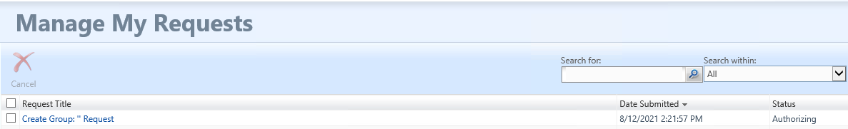

Create an ORG Group
Aim | Create an ORG group
Access Role | MIM User, or MIM Administrator if this is the first group in a new OU.
The process is much the same as for a UDC group, with the following minor changes.  Select “ORG” as the Category. | 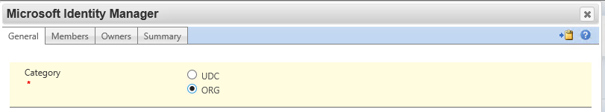
When selecting the parent, if this is the first ORG group in a new OU, switch the “Search within” option to “All OrgUnits” and search for the org unit.  NOTE: The process “Add a new Organisation Unit” will need to have been followed first. | 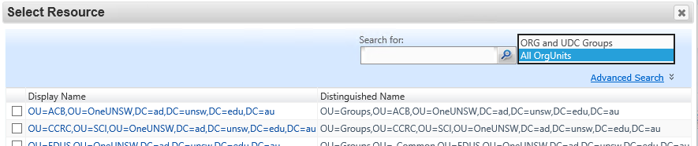

Modify a Group’s members
Aim | Change a group’s members
Access Role | MIM User
Locate the group to be changed and click to open it,  Change to the Members tab | 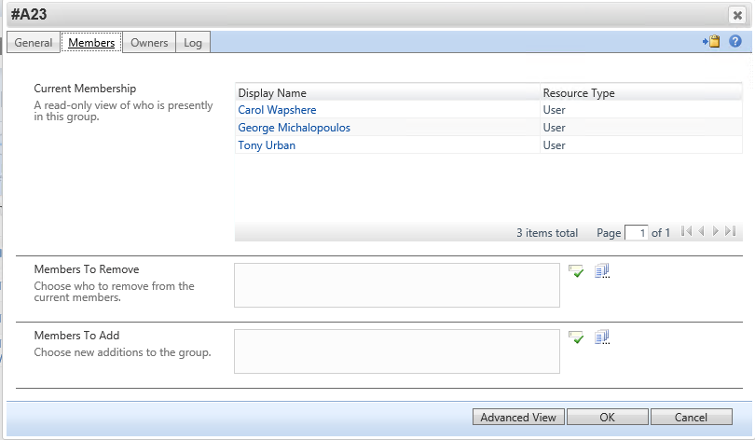
To Add members, click the Browse button next to the “Members to Add” box and find the members to add. | 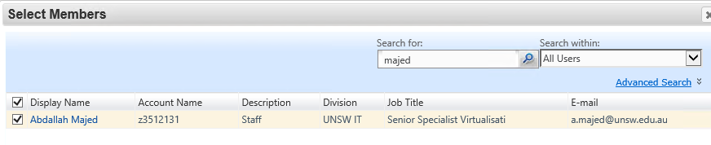
Depending on the type of group and the requestor different options are offered under “Search within” and be able to add groups and/or users. | 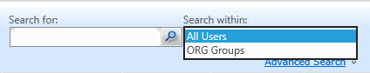
To remove members, click the Browse button next to the “Members to Remove” box and tick the members to remove. | 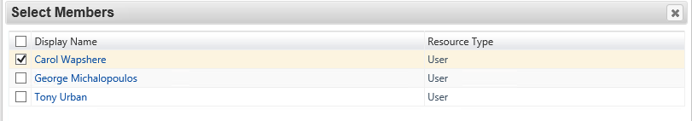
Click OK | 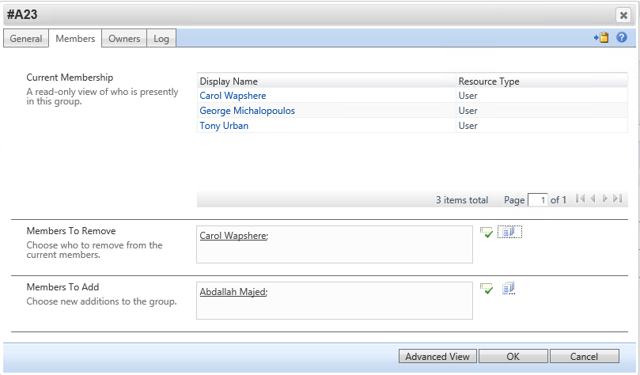
Click Submit.  An approval process may be triggered – if so another screen with the message “Pending approval” will be shown. | 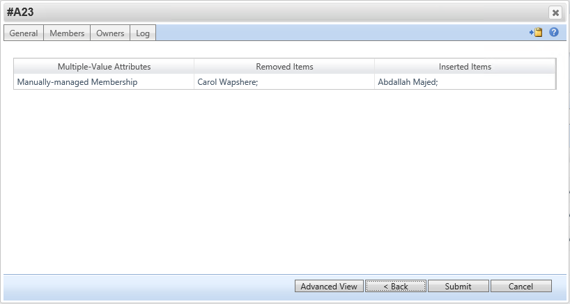

Add members to multiple groups
Aim | Add members to multiple groups
Access Role | MIM User
Search for a tick the groups to be modified | 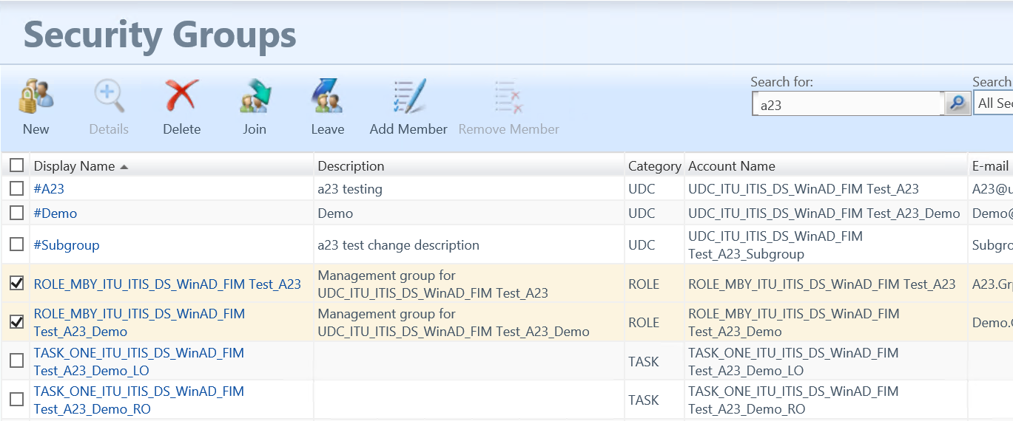
If different search strings need to be entered to find all the groups, any selected groups remain selected. Refer to the “Selected Items” list at the bottom of the page to see all selected groups. | 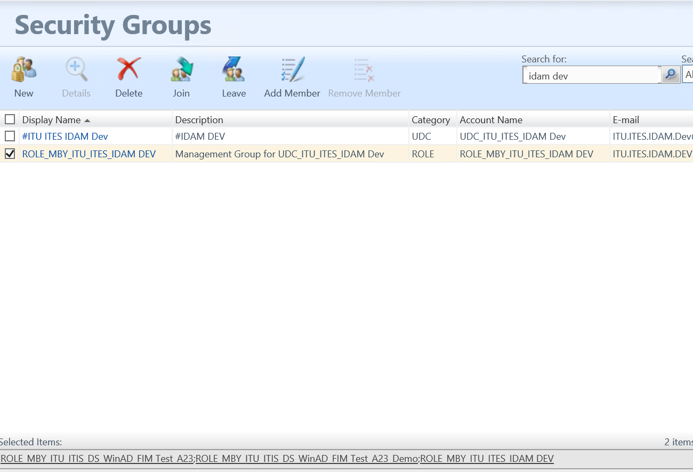
Click the “Add Members” button,  Use the lookup button to fine the user/s to add to the group,  Click Next. | 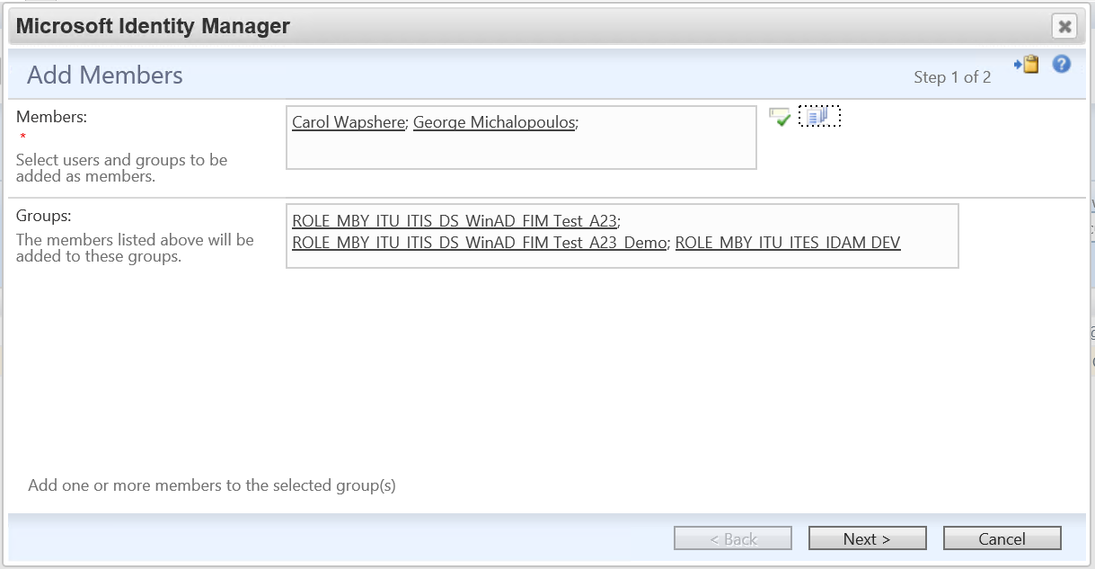
Review the changes then click “Submit” to request the changes,  Approvals will be triggered if applicable. | 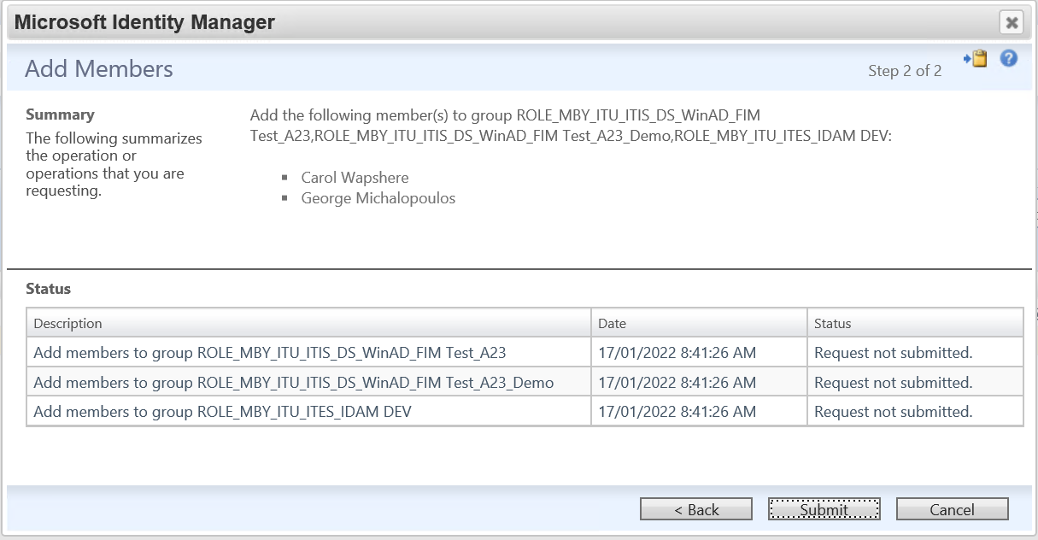

Mail Enable a Group
Aim | Convert an ORG or UDC group to a mail-enabled Security group.  Option is not available for ROLE groups (which are mail-enabled by default) or TASK groups. Option cannot be un-ticked once set.
Access Role | MIM User
Locate the group and open it.  Tick the “Mail Enabled” option and then submit the change.  Depending on the requestor there may be an approval process at this point. | 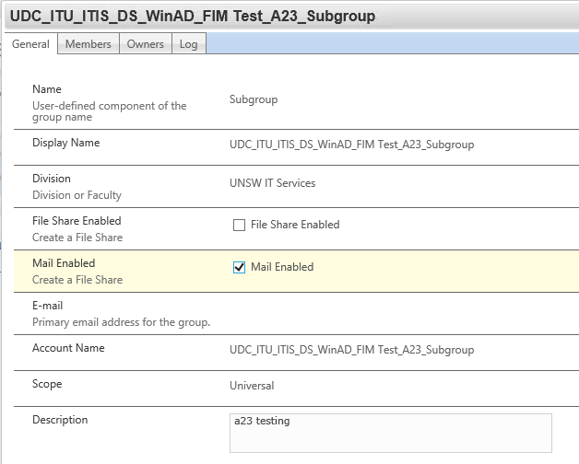
Following completion of the change, an email address and new Display Name will be generated for the group.  Note that there will be a delay before the group is available in Outlook. | 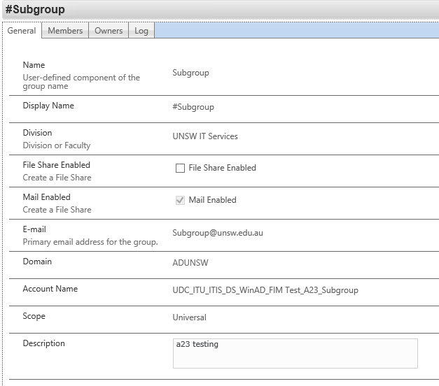

File Share Enable a Group
Aim | Create a file share for an ORG or UDC group.  Option is not available for ROLE or TASK groups. Option cannot be un-ticked once set.
Access Role | MIM User
Locate the group and open it.  Tick the “File Share Enabled” option and then submit the change.  Depending on the requestor there may be an approval process at this point.  Note that there will be a delay before the file share is created. | 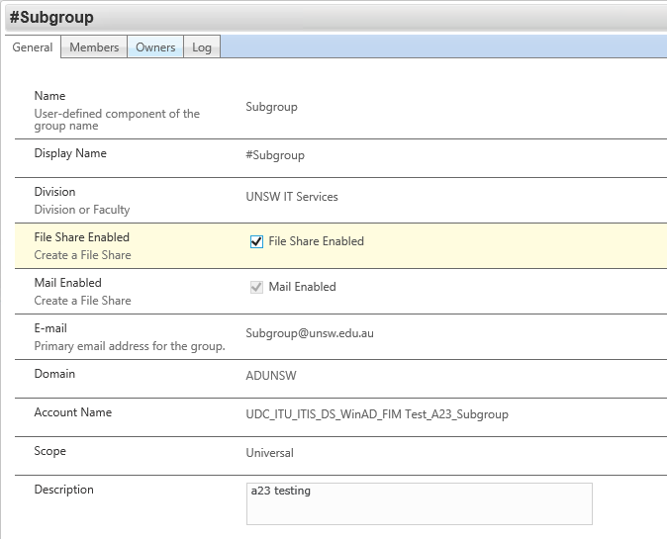

Approvals

View or Cancel a Pending Request
Aim | Check the status of a request that is pending approval
Access Role | Creator of the request
Click the “Manage My Requests” menu option on the left side menu to see any recent requests. | 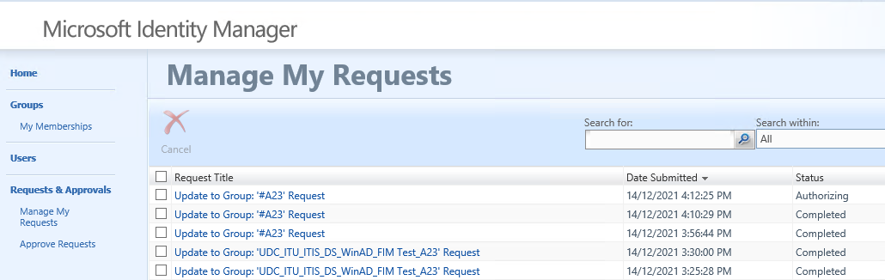
To cancel a request that is in the “Authorising” state, tick to select and then click “Cancel”. | 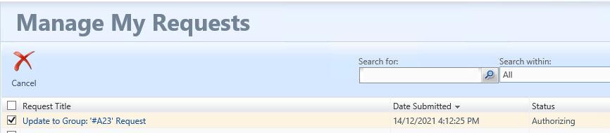

Respond to a request for approval
Aim | Accept or reject a request
Access Role | Approver
All approvers will receive an email notifying them that a request requires approval.  Either click the link in the email or open the MIM Portal and navigate to the “Approve Requests” page. | 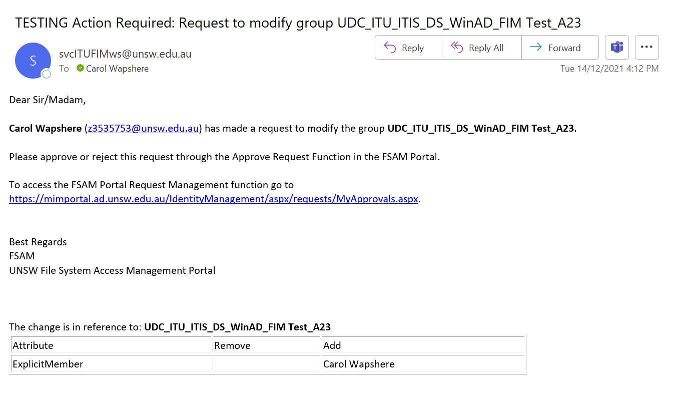
To see more information about the request, click on its Title and navigate to the “Detailed Content” tab. | 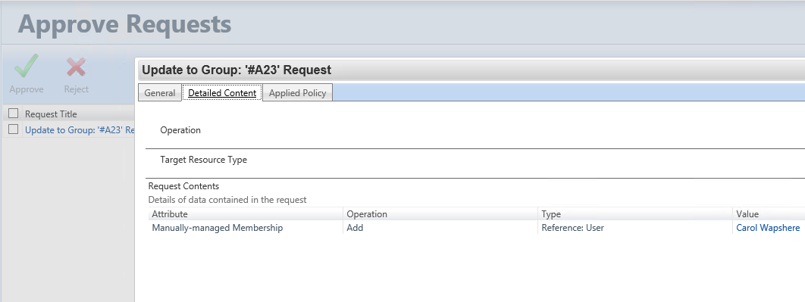
To complete the request, tick to select and then click either “Approve” or “Reject”. | 